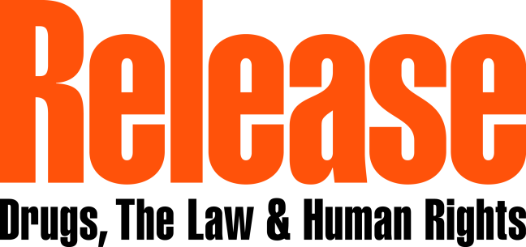
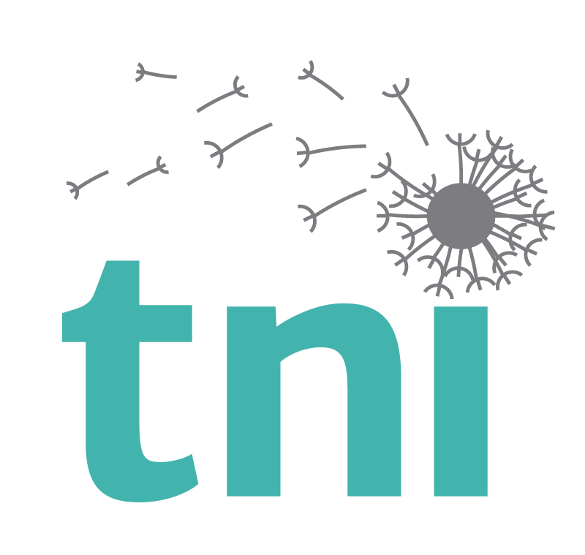

SOUTH EAST ASIAN ADVOCACY FELLOWSHIP PROGRAM
ON DRUG POLICY REFORM

ABOUT THE FELLOWSHIP
The Transnational Institute (TNI) and Release are calling for applications to the 2017 South East Asian Advocacy Fellowship Program on Drug Policy Reform. This program supports those working in sectors related to drug policy in order to increase their understanding of international drug policy reform issues, to improve their advocacy skills, and to enhance their capacity in working with the media on drug policy. The fellowship seeks to increase the capacity of emerging and new leaders in drug policy reform in the Southeast Asian region, including people not necessarily working full-time on drug-related issues. Government officials are also welcome to participate.
FELLOWSHIP OBJECTIVES
The objectives of the fellowship are for the participants to:

- increase their knowledge of global drug policy reform issues;
- increase their understanding of the international drug control system and conflicts with other United Nations priorities;
- have awareness of the drug policy reform landscape and key figures within that movement;
- establish links with relevant actors working in the drug policy field;
- build and develop communications skills, including for media interviews, press releases, press databases, public speaking;
- have an understanding of the tools for debate, to challenge anti-reform positions;
- Improve their confidence as drug policy advocates both through participation in the program and through ongoing support from the host organization.

FELLOWSHIP AGENDA The two-week program will be based with two drug policy organizations: one is Release in London, United Kingdom, and the other one is Transnational Institute (TNI), based in Amsterdam, the Netherlands. Applicants can indicate their preference.
Dates: The two-week program will take place between 2 July 2017 and 14 July 2017 in London and between 10 June 2017 and 25 June 2017 in Amsterdam. The fellowship training grants will cover travel, lodging and meals.

The program includes the following topics:

- Global overview of drug policy reform: current debates and challenges
- Harm reduction and proportionality in drug policy
- The international drug control system and its functioning
- Overview of international human rights in the context of drug policy
- Drug policy developments in (SE) Asia
- Effective campaigning
- Media and public engagement

ELIGIBILITY
Successful candidates will have a track-record of public engagement in human rights, law, or relevant government experience. Ideally their work should intersect with the issue of drug policy and/or human rights. Priority will be given to these applicants. However, we also welcome applications from those working in drug policy reform or another relevant field (e.g., public health) at the local, national or international levels.
We are looking for candidates from the following countries: The Philippines, Myanmar, Indonesia, Thailand, China and Cambodia.
Previous fellows have worked in drug policy NGOs, at law enforcement agencies, in national governments, in health care facilities, and at universities, among other organizations. Please note that before receiving the fellowship, finalists will be asked to present a letter from their employer agreeing to their two-week participation in the course.
Applicants must have a strong command of the English language to participate in the course.
Please note: the purpose of this program is to promote the capacities of both new advocates and individuals who are emerging leaders in drug policy reform. Current recipients of the Open Society Foundations are eligible to apply for the fellowship.
HOW TO APPLY?

To be considered for the program, applicants should submit the following documents in English as .doc or .pdf attachments, together to one email by 18 April to seafellowstraing@gmail.com

- Application – Please see the application form attached. Note that the applicant is asked to address all prompts, including providing short-answer responses to four questions.
- Curriculum Vitae (CV) – The CV should specify the applicant’s academic and professional background, including a detailed description of previous employment, a list of academic and policy projects in which the applicant has been involved, public engagement record, and honors (including scholarships and fellowships).
- Writing sample (optional) – The sample must be in English and should demonstrate the candidate’s expertise in a field related to drug policy. The writing sample should not exceed two pages.
FELLOWSHIP TERMS

The Advocacy Fellowship program in London provides funding to a maximum of four people to attend the two-week training program on drug policy reform. The training in Amsterdam can place six people. The placement decision will be made by a program selection committee comprised regional experts and representatives from Release and TNI.

Participation in the fellowship is contingent upon acquiring a letter of support from the finalist’s employer and proper immigration and travel authorizations.

The Fellowship is designed to expose participants to international networks of global drug policy and to connect them with various advocates at the host organization, in their home country or region, and globally. Participants are expected to take skills gained during the fellowship back to their home country, further promoting drug policy reform through various projects and initiatives in their home contexts. The program is designed so that the connections and international networks will serve as a resource and support for the fellow both during and following their fellowship experience.

TIMELINE

Applications open: 28 March 2017
Application due date: 18 April 2017
Selection: Successful applicants will receive a response by 1 May 2017.

