"This essay was submitted as part of Transnational Institutes call for papers for its State of Power 2015 report. The essay was not shortlisted for the final report and therefore TNI does not take responsibility for its contents. However the Editorial Board appreciated the essay and it is posted here as recommended reading."

Differential Taxation:
A Convergence of Interests between American Banking and Government

Mladen Ostojić

Abstract

This paper demonstrates that the interests of American banking and government have converged after the early 1980s and relates this trend to modern financial deregulation, revealing a symbiosis that would later influence the global financial crisis of 2007-2008. An examination of corporate profit and taxation in the United States reveals an anomaly: from the early 1980s until the financial crisis, banking profits after tax sharply outpaced those of the corporate average despite their effective tax rates having simultaneously increased relative to those of the corporate average. These conditions thereby created a mutually beneficial relationship between American banking and government in which banks earned higher profits and the government earned higher tax revenues. However, this tax arrangement ultimately depended on unsustainably deregulated banking profits, and fell apart during the financial crisis of 2007-2008.

Introduction

Since the late twentieth century, our world has been subject to an extraordinary rise in the power of finance as a leading engine of political economic activity. Modern finance, entrenched in the commanding heights of an increasingly integrated global marketplace, has helped push globalization forward and internationalized capitalism like never before. Initially, this establishment formed a power dynamic that simply seemed too big to fail, but its ultimate limitations would eventually be exposed during the financial crisis of 2007-2008. Although this crisis began in American banking, it quickly spread to be felt around the world, and its residual effects continue to be felt in what has come to be known as the Great Recession. That a crisis with such significant global impact began in the banking sector of a single country – even one as important as the United States – attests to the globalized nature of modern finance, engendering a deep reassessment of financial stability both in the United States and abroad. However, while this recent crisis has certainly demonstrated that contemporary finance is a heavily transnational activity, the role that American banking played in triggering it remains important to the story and thus deserves special attention.

Although the American origin of the financial crisis of 2007-2008 is common knowledge, much of the surrounding analysis has focused on particular instances of deregulation. Despite the admittedly useful understanding advanced by this conventional approach, which correctly notes the unstable power given to American banks in recent decades, its search for a deregulatory sine qua non may have overlooked other important factors. One seemingly unremarkable yet ultimately crucial part of this ongoing story is taxation: a topic too often neglected amidst the overwhelming complexity of modern globalization, taxation’s ability to redistribute wealth and income must not be overlooked. Accordingly, no matter how complex modern economics or the theories explaining it have become, taxation remains of utmost concern to even the most advanced of modern capitalist business interests and must be properly understood as a regulatory tool in its own right. Without question, the American banking system, despite all of its modern complexities, is no exception to this rule, and there must be room for taxation in understanding this most recent of crises.

By focusing on the American aspect of this financial crisis through the lens of taxation, we will see how booming banking profits before the crisis padded government coffers, revealing a relationship between banking and government beyond that of deregulation and further cementing the centrality of American affairs in this ultimately global crisis. But to explore the financial crisis of 2007-2008 in terms of American banking taxation, our focus must also shift from qualitative underpinnings to engage in quantitative data. In particular, banks must be treated as corporations that are taxed on their profits and, like most other corporations, also tend to measure their bottom-line performance in terms of these same profits. In this respect, corporate taxation presents an obstacle to the objectives of banking as a money-making venture. This otherwise unremarkable corporate reality becomes a great deal more significant when considering that not all corporations face the same tax burden. Because effective corporate tax rates can vary, thus subtracting different amounts of profit from even the most similar of corporations, differential taxation must be viewed as a moderator of relative corporate performance. And when comparing corporate profits and effective tax rates across corporate sectors, American banking reveals some very stark disparities.

Contrary to what one might expect, banking profits have actually run against the grain of differential taxation: the sector performed best when its relative tax burden was heaviest – in the decades preceding the financial crisis of 2007-2008. While American banks enjoyed effective tax rates significantly lower than those of the corporate average since at least the 1940s, this differential tax advantage started to decline following the 1980s. Other things being equal, one would expect that a rising relative tax burden would serve to stifle corporate performance. But instead, American banks after the 1980s actually outperformed other corporate sectors, revealing an even stronger opposing force that more than compensated for the loss of their tax advantage and thus allowed them to outpace their competitors’ profits not only before tax but also after tax. And although a quantitative study of profits and taxation cannot describe the reasons behind this oddity, it is rather telling that such a tax-defiant burst of corporate performance should have taken place in a sector reputed for excessive deregulation – and especially if it triggered a financial crisis.

If this recent crisis has indeed exposed a want of financial regulation, then the origins of any relevant deregulation might be found in this banking performance after the 1980s. Corporate taxation, understood as a regulatory tool that moderates corporate profits, seems to have been more than offset in recent decades by heavy financial deregulation, and any deregulation that allowed American banks to enjoy improved performance after the 1980s effectively outstripped the tighter regulation presented by increased tax rates. And with banking profits outpacing their corporate competitors amidst higher tax rates, government authorities also reaped the benefits of higher contributions to tax revenues. This mutually beneficial outcome reveals a bond between banks and fiscal authorities, held together by a curious deregulatory arrangement that allowed higher banking profits after tax despite increased tax rates. But this scheme did not survive the financial crisis, and its abrupt reversal disrupted its American participants before the globalized reach of international finance spread the crisis to the rest of the world.

And while this quantitative study can only hope to speculate over the arrangement itself, offering relatively little legal background and nothing in the way of theory for support, profit and tax data are sufficient to suggest its existence and consider its implications. To this end, this paper will proceeds in two sections: the first focused on banking and the second on the government. The first of these sections will consider the profit and taxation trends of the banking sector, demonstrating that the decades-long differential tax advantage enjoyed by American banks has yielded to the curious increase in both profits after tax and effective tax rates after the 1980s. The second section will assess the contribution of corporate tax revenues to government receipts, showing a sharp rise in the importance of banking taxation after the 1980s. Taken together, this investigation will demonstrate the importance of taxation in the recent history of American banking, revealing a deregulatory convergence of interests that has benefited both banking and the government until the financial crisis of 2007-2008.
1. The Differential Taxation of American Banking

Before considering its impact on the government, let us explore American banking itself. In order to assess the development of banking profits after tax and effective tax rates, we must situate these variables within their broader corporate realm and make a comparison with other corporate sectors that are subject to the same type of taxation. Other things being equal, banking profits after tax should outpace the corporate average given lower effective tax rates and conversely lose ground to the corporate average given higher effective tax rates. However, the data at hand have instead revealed a striking deviation from these expectations – after the 1980s, banks have outperformed other corporations precisely as they lost their differential tax advantage. The loss of this historically preferential tax position thus coincided with a lasting transformation in banking performance that has gone uninterrupted until the financial crisis of 2007-2008. Such an anomaly certainly warrants closer inspection and further deliberation will demonstrate it as congruent with heavy deregulation of the banking sector.

Figure 1 traces the American history of effective corporate tax rates from 1929 to 2013, and juxtaposes it against that of effective banking tax rates from 1929 to 2011. Also, banking profits after tax are expressed differentially as a percentage of corporate profits after tax from 1929 to 2011. Our differential profit data are based on raw figures and measure domestic profits, while our effective tax rates are derived from these profit data and dependent on the difference between profits before and after tax. Mathematically, this difference is equivalent to taxes paid and dividing it by profits before tax yields our effective tax rates in percentage terms:

effective tax rate = ((profits before tax - profits after tax) / profits before tax) * 100

These data track both the differential taxation and the differential performance of the banking sector, with the difference between banking and corporate effective tax rates measuring the extent of the former and banking’s share of corporate profits the pace of the latter.
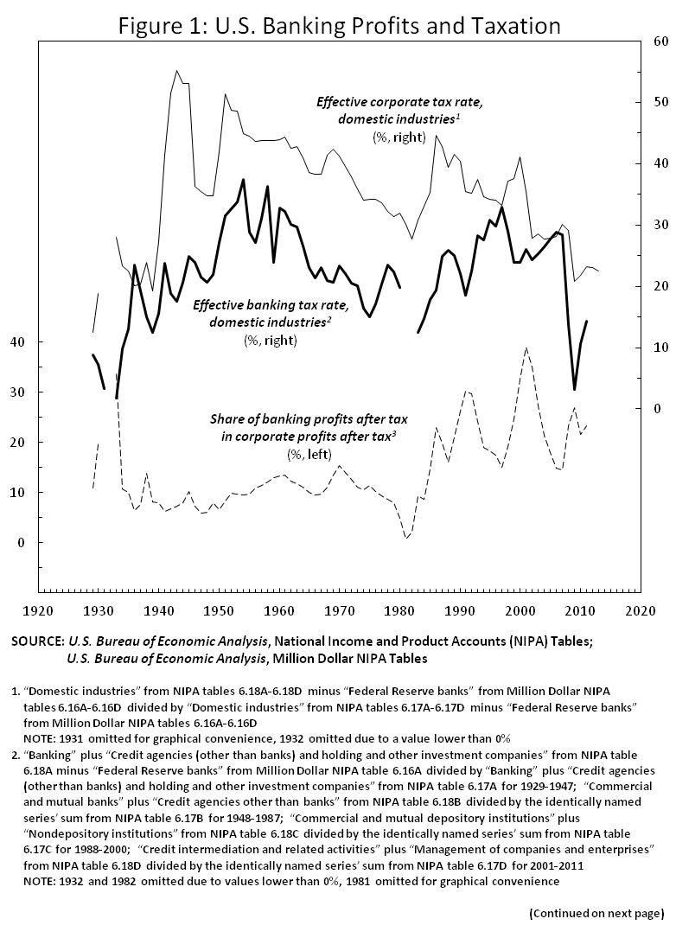
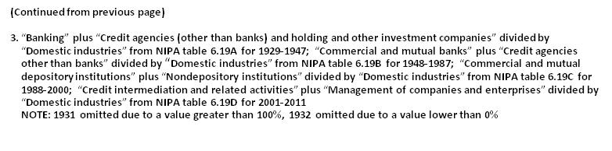
Bearing in mind that our primary interest is in banking developments since the 1980s, Figure 1 reveals two relevant periods, the first lasting from the early 1950s until the early 1980s and the second following the early 1980s. The first of these periods exhibits relatively stable data marked by gradual but significant reductions to both corporate and banking effective tax rates. During this period, effective banking tax rates were far lower than effective corporate tax rates, granting banks a heavy differential tax advantage over other corporations. Amidst this tax advantage, banking profits after tax initially outpaced those of the corporate average but eventually faced an abrupt collapse by the early 1980s. The second period, taking shape in the wake of this collapse, would exhibit a sharp reversal of preceding trends that drastically transformed American banking. With effective corporate tax rates now falling and effective banking tax rates now rising, this period completely ended the banking sector’s longstanding tax advantage by the 1990s. However, this did not prevent banks from recovering and later exceeding their former performance, and their profits actually outpaced those of the corporate average, although with increased volatility. Ultimately, this tax-defiant banking profitability ended with the financial crisis of 2007-2008, and a new differential tax advantage took hold thereafter to sustain banking performance. To better understand the trends in Figure 1, let us detail both delineated periods in turn.

1.1 American Banking in the Postwar Decades

During the decades following the Second World War, we can see that effective banking tax rates were already a great deal lower than effective corporate tax rates (on average 14.8% lower from 1946 to 1980). This tax disparity first took shape during the war itself, with effective corporate tax rates in the 1940s almost tripling to their highest levels in Figure 1 while those of banks remained relatively stable, endowing the banking sector with a differential tax advantage that persisted until the 1980s. Although it is unclear exactly how or why such a heavy and extensive tax differential might have come about, it seems reasonable to suspect some sort of intervention by the American government, given that matters of taxation ultimately stem from state authority.

Regardless, the impact of this taxation on banking performance also deserves attention, and before their early 1980s’ collapse, banking profits after tax expanded for much of the period. Recording steady gains over the corporate average with few interruptions for over 20 years, these profits rose as a share of the corporate total from 1947 to 1970 but began to fall thereafter. Despite sustaining their tax advantage, banking profits after tax entered decline after 1970, eventually leading to an abrupt collapse that would result in unprecedented lows in the early 1980s. Therefore, this same differential tax advantage led to two opposite results for banking profits after tax – steady differential gains from 1947 to 1970 and mounting differential losses from 1970 to 1981. Given this reversal, the longstanding benefits of differential taxation proved impotent and banking profits eventually collapsed in the early 1980s.

One possible explanation for this collapse is the so-called Volcker Shock and its related savings and loan crisis. In the 1970s, the American economy experienced high inflation, with prices rising at troubling rates and government authorities unable to stop them. After 1979, the Federal Reserve intervened through an aggressive use of contractionary monetary policy, tightening the money supply so as to restrain borrowing and inflation (Greider, 1987). However, the apparent success of this monetary activism also caused a recession marked by higher interest rates that hit moneylending institutions like banks especially hard, which might explain why banking profits plummeted to such depths. However, this collapse of banking profits did not last long, and the banking sector would quickly recover and go on to thrive amidst a very different tax dynamic.

1.2 American Banking since the 1980s

After the early 1980s, banks recovered and re-emerged as a corporate powerhouse, their profits after tax outpacing the corporate average despite losing their tax advantage. Although the banking sector’s tax advantage initially reappeared after its profit collapse, it gradually deteriorated amidst rising banking and falling corporate effective tax rates. And by the 1990s, American banks eventually faced a tax burden comparable to that of the corporate average, thereby completely losing their tax advantage in the process. However, rather than to lose ground to their corporate competition amidst such a loss, banks not only managed to recover but in fact sharply outperformed other corporations, expanding to account for their highest shares of after-tax corporate profits in Figure 1. This shift reveals a transformation of the banking sector that raised its profits before tax so much that its banking profits after tax also increased despite their simultaneously increasing tax burden. But these newfound profits also exhibited much higher volatility, exposing the altered character of the banking sector after the 1980s. Of particular note, this volatility supports the account of a heavily deregulated corporate sector assuming dangerous amounts of risk in order to realize extraordinary but unstable profitability that eventually led to financial crisis both at home and abroad.

As it turned out, this otherwise favourable deregulatory arrangement was interrupted by the financial crisis of 2007-2008 and its impact on the American banking sector. Again, this crisis brought about differential tax rates comparable to those of postwar decades, and these actually sustained banks’ after-tax profit levels despite the onset of the crisis. As a result, the banking sector’s after-tax performance did not suffer during this crisis, and its share of total corporate profits after tax maintained the levels seen since the late 1980s. This continuity contradicts the notion that banks struggled during the crisis and Great Recession, and especially since it involved the sector as a whole rather than only select banks. At the same time, it is also true that many banks fell victim and there were certainly losers amidst these aggregate gains. The frequency of bank failure before and after the financial crisis demonstrates these losses well – while only 25 bank failures occurred from 2001 to 2007, another 25 took place in 2008 alone, another 140 in 2009, and a further 177 in 2010 (Federal Deposit Insurance Corporation, 2014). Nevertheless, the banking sector as a whole retained its after-tax profit levels despite this recent crisis, and this striking impunity was largely due to its renewed differential tax advantage.

Overall, the relationship between banking performance and taxation followed patterns, but these patterns changed drastically over time in a manner that appears inconsistent. If the sector’s differential after-tax profit gains made sense amidst preferential taxation, then the same can hardly be said when it lost out under the same set of circumstances, and even less so when it gained again despite losing this tax advantage. Presumably, this is because circumstances were not the same and other forces were at work. Again, while this investigation cannot offer any conclusive explanations with sufficient certainty, the conventional wisdom surrounding the recent crisis often cites financial deregulation, which may hold answers that can at least provide for meaningful speculation.

One often-cited deregulatory culprit is the 1999 repeal of the 1933 Glass-Steagall Act, which is said to have destabilized banks and thus led to the crisis (Blackburn, 2008). However, our data suggest that the most tax-defiant banking profit trends took hold after the early 1980s. Therefore, if the growth and volatility of these profits are any reflection of financial deregulation, then any thorough analysis of related deregulation must begin much earlier than 1999. And while the history of any such deregulation lies far beyond the quantitative basis of this investigation, its apparent application after the early 1980s is congruent with the aggressive neoliberal rhetoric of the Reagan administration and the subsequent popularity of deregulatory policies. Furthermore, this deregulatory drive would subsequently find support from authorities in both the United States and abroad, exporting deregulation to later catalyze the financial crisis along global lines. That said, any talk of deregulation should thus incorporate the government authorities behind it, and especially if simultaneous growth in profits and tax rates has boosted tax revenues. Indeed, this arrangement forms a two-way street in which banks not only earn profits but also pay taxes, and we must therefore examine the other party to the arrangement: the government.

2. Banking Taxation and the American Government

As we have seen, the historical development of banking taxation strongly suggests that the sector’s performance over recent decades was due to heavy deregulation. However, both taxation and deregulation are legislative matters stemming from state authority, rendering our investigation incomplete without a closer look at government involvement. While analysis of banking covered the business side of this deregulatory arrangement, its effects on the government authorities behind it have yet to be seen. To explore them, we must recognize that tax revenues from corporate profits are an important component of government receipts, meaning that the government has a budgetary dependence on corporate profitability. Moreover, deregulation that might influence corporate profitability can therefore impact on tax revenues, making the government a potential beneficiary of policies otherwise aimed at the private sector.

Thus, if the rapid expansion of banking profits after the 1980s was due to deregulation, then the government authorities behind its development cannot be considered impartial. On the contrary, with banks experiencing sharp increases to not only their profits but also their effective tax rates, tax revenues from the sector must also have increased – much to the benefit of the U.S. Treasury. As we will see, both banking profits after tax and government tax revenues have increased, amounting to a mutually beneficial affair in which both banking and government reaped significant rewards. Through taxation, American authorities have thereby shared the spoils of financial deregulation, turning the sector into a fiscal cash cow and entrenching government interest in its profitability. But with the financial crisis of 2007-2008 later threatening deregulated banking profits, this marriage of banking and government grew much less favourable for both parties.

Figure 2 compares tax payments from the banking sector to those from all corporations, expressing both as percentage shares of government current receipts. In addition, government receipts are shown as percentage shares of gross domestic product (GDP). All three series begin in 1929, with corporate tax payments and government receipts both ending in 2013 and banking tax payments ending to 2011. Through tax payments, we can assess the importance of banking and corporate taxation to government finance and therefore the extent of government dependence on banking and corporate profits. At a glance, both banking and corporate tax payments reveal trends that are divisible into two periods, periods that roughly overlap with those seen in Figure 1. This similarity is only to be expected, since tax payments are the product of effective tax rates and profits before tax:

tax payments = effective tax rate * profits before tax

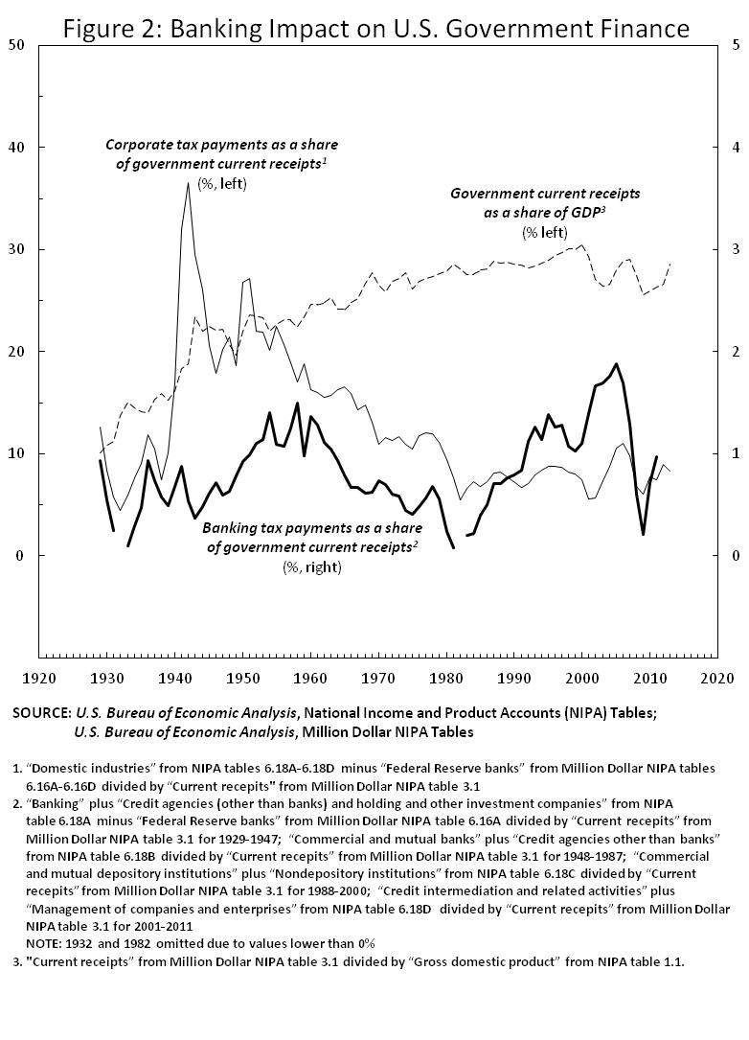
2.1 American Banking and Government in the Postwar Decades

During the postwar decades, both corporate and banking tax payments faced decline until the early 1980s, their shares of government receipts shrinking for about 30 years. Corporate tax payments, after tripling to over one third of government receipts during the Second World War, declined sharply but recorded relative highs well into the 1950s. However, from 1951 to 1982, they recorded an almost fivefold reduction to settle on slightly over 5% of government receipts. This drastic decrease meant that over 20% of American government receipts had no longer come from corporations, thereby greatly reducing the importance of corporate tax payments for government finance. Moreover, although this shift away from corporate taxation did not extend beyond the early 1980s, the lows reached in the process persisted thereafter. Their tax payments thus reduced, corporations lost significant importance as a source for government finance.

In the meantime, banking taxation also experienced a comparable but amplified decline, with banking tax payments as a share of government receipts decreasing from highs in the 1950s to reach record lows by the early 1980s. After their postwar peak in 1958, banking tax payments entered a period of heavy decline and reached negative values in 1982. Although this collapse of banking tax payments proved deeper than that of the corporate totality, it also involved much less money and was accordingly less significant for government finance. Even so, that banks had previously accounted for over 1% of government receipts is far from a trivial figure, as it means that a significant portion of the government was financed by a single corporate sector. But after collapsing in 1982, banking tax payments no longer mirrored the corporate whole, quickly recovering and settling on an independent path that proved quite lucrative for the government.

2.2 American Banking and Government since the 1980s

After the early 1980s, banking tax payments diverged from those of the corporate total, rapidly outpacing them as a share of government receipts until the financial crisis of 2007-2008. Corporate tax payments, under rising profits and falling effective tax rates, exhibited rising volatility since the early 1980s but fluctuated without long-term growth, bouncing between roughly 5% and 10% of government receipts. While not insignificant, these contributions were no larger than those seen during the 1930s’ Great Depression, keeping corporate taxation far less important for government finance than during the postwar period. That said, these recently stagnant corporate tax payments did not mean uniformity across different sectors, and banking tax payments sharply diverged from those of the corporate totality after the 1980s.

Banking tax payments, under faster profit growth and increasing effective tax rates, have developed quite differently from the stagnation of recent corporate tax payments, facing rapid expansion as a share of government receipts until the financial crisis of 2007-2008. After their collapse in 1982, banking tax payments quickly recovered and grew rapidly for over 20 years, matching their late 1950s’ shares of government receipts by the 1990s and eventually peaking at 1.9% in 2005, their highest value in Figure 2. This figure may seem unimpressive, but represents nearly one fiftieth of the government being financed by only a single corporate sector. However, these highs did not survive the financial crisis of 2007-2008 and collapsed thereafter, with banking tax payments as a share of government receipts plummeting to just 0.2% by 2009, thereby reversing the mutually beneficial tax arrangement between American banking and government.

2.3 The Converging Interests of American Banking and Government

If deregulation led to increases in both banking profits and banking tax payments alike, then this deregulation has benefited not only corporate but also government interests. Moreover, if this same deregulation was responsible for triggering the financial crisis of 2007-2008, then it also ensured the eventual collapse of the very arrangement that it originally created, thus suddenly straining the finances of both banking and government in the process. That said, given the government’s increased reliance on the taxation of deregulated banking profits, this financial crisis and the resultant Great Recession turned out to be much costlier affairs – not only were the policies employed to mitigate these downturns some of the costliest in history, but they would have to be financed without such an affluent banking taxation.

Unsurprisingly, the first thrust of these policies sought to bail out the financial sector, resulting in the outgoing Bush administration’s Emergency Economic Stabilization Act of 2008 and its initial budgetary commitment to “purchase or insure up to $700 billion of troubled assets” (Congressional Budget Office, 2009, p. 1). Meanwhile, intervening with expansionary monetary policy that included the irregular methods of quantitative easing, the Federal Reserve began acquiring troubled assets with newly created money while paying interest on excess bank reserves that within months ballooned from a few billion to almost $800 billion by the end of 2008 (Federal Reserve Bank of St. Louis, 2014). Soon after this preliminary bailout of the financial sector, the Obama administration initiated the American Recovery and Reinvestment Act of 2009, effectively creating a much more widespread stimulus package that initially committed another $787 billion. As the largest stimulus package ever, it also amounted to the largest budgetary deficit since the Second World War and created the need for heavy deficit spending ever since (Albo et al., 2010).

Opposite these expenses, a single corporate sector’s tax payments might seem trivial, but the crisis still meant about 1% of government receipts no longer coming from banks. Put into perspective, annual government receipts since the crisis have averaged some $4 trillion, making this lost taxation cost in the order of tens of billions of dollars per year, money that could otherwise have been spent to finance the aforementioned stimuli. What is more, while banks remain important to the recovery from the Great Recession, they themselves have yet to recover. For one, the Federal Reserve has yet to abandon the monetary injections of quantitative easing and excess bank reserves have grown since 2008 to exceed $2 trillion by mid-2013 (Federal Reserve Bank of St. Louis, 2014). With the banking sector parking trillions that could instead be lent out, it has rendered expansionary policy relatively impotent as a means for any effective long-term stimulus, thereby keeping the financial system in a sluggish state and holding back recovery.
Moreover, the likelihood that banks will regain confidence in conventional investments is even further diminished by new regulations introduced since the initial financial crisis of 2007-2008. Namely, the Dodd-Frank Wall Street Reform and Consumer Protection Act of 2010 introduced measures that have since increased transparency requirements and restricted speculative investments, thus effectively outlawing many activities that banks engaged in to achieve their pre-crisis profitability (United States Senate Committee on Banking, Housing, and Urban Affairs, 2010). Long-term stability aside, such reforms could not have been immediately helpful to the struggling banking sector. And indeed, the frequency of bank failure in the United States still surpasses that of pre-crisis years, with 51 failed banks in 2012 and 24 in 2013 (Federal Deposit Insurance Corporation, 2014). In summary, this crisis has cut into the finances of both banking and government, dismantling the longstanding deregulatory tax arrangement between banking profits and government tax receipts to leave both parties – and the world – in a recession.

Conclusion

Having traced the historical development of American banking, there remains little doubt about the importance of its taxation in the decades leading up to the financial crisis of 2007-2008, as it resulted in a deregulatory convergence of interests between banking and the government. Banks, outperforming after-tax corporate profits despite losing their historical tax advantage after the 1980s, certainly appear to have benefited from heavy deregulation in recent decades. This deregulation, strong enough to skyrocket differential performance despite a waning differential tax advantage, thus transformed the American banking sector into a formidable corporate powerhouse. At the same time, the government also reaped rewards by receiving more of its funds from banks.

The result – increases in banking profits and tax contributions to government receipts –reveals a deregulatory tax arrangement that served both banking and the government. Furthermore, given that this arrangement only collapsed during the financial crisis of 2007-2008, a crisis allegedly caused by the very same deregulation that had originally created the arrangement, it also appears to have ended in much the way as it began. And although the authorities seem hopeful, resurrecting their former corporate cash cow with a score of new regulations appears to be futile, and this previously imposing sector remains indefinitely reliant on stimulus funding. And with economic trouble still lingering, the relationship between American banking and government faces an uncertain future – as does the individual fate of both sets of institutions.

But even more concerning than this American story is the global scope of these events, as what started in the United States has since spread through the international finance of our globalized world to engulf most of its countries in its worst recession in decades. Indeed, if the global economy can be brought to its knees by the excessive deregulation of only one banking sector, then it is difficult to be optimistic about the future of twenty-first century capitalism. Moreover, if comparable financial deregulation in other countries played its part in this recent crisis – and especially if it involved converging interests with (and bailouts by) their host governments – then financial and corporate power appears to have permeated state authority around the world to an alarming degree. Therefore, while the recent financial crisis remains most closely tied to the American experience, its global scale begets additional research of banking taxation in both the United States and other countries.

Biography

Mladen Ostojić is an independent researcher based in Toronto, Canada. He holds a Master of Arts in political science and an Honours Bachelor of Arts in economics and political science from York University.

Contact: ostojicmlad@gmail.com

References

Albo, G., Gindin, S., & Panitch, L. (2010).
In and out of crisis: The global financial meltdown and left alternatives.
Oakland: PM Press.

Blackburn, R. (2008). The subprime crisis. New Left Review, 50, 63-106.

Congressional Budget Office. (2009).
The Troubled Asset Relief Program: Report on Transactions Through
December 31, 2008. Washington, D.C.: Congressional Budget Office.

Federal Depository Insurance Corporation. (2014, August 19). Failed Banks List.
Retrieved from https://www.fdic.gov/bank/individual/failed/banklist.html

Federal Reserve Bank of St. Louis. (2014, August 7).
Excess Reserves of Depository Institutions.
Retrieved from http://research.stlouisfed.org/fred2/series/EXCSRESNS

Greider, W. (1987). Secrets of the temple: How the Federal Reserve runs the country.
New York: Simon and Schuster.

United States Bureau of Economic Analysis. (2014). National Economic Accounts.
Retrieved from http://www.bea.gov/national/index.htm

United States Senate Committee on Banking, Housing, and Urban Affairs. (2010).
Brief summary of the Dodd-Frank Wall Street Reform and Consumer Protection Act. Retrieved from http://www.banking.senate.gov/public/_files/ 070110_Dodd_Frank_Wall_Street_Reform_comprehensive_summary_Final.pdf

