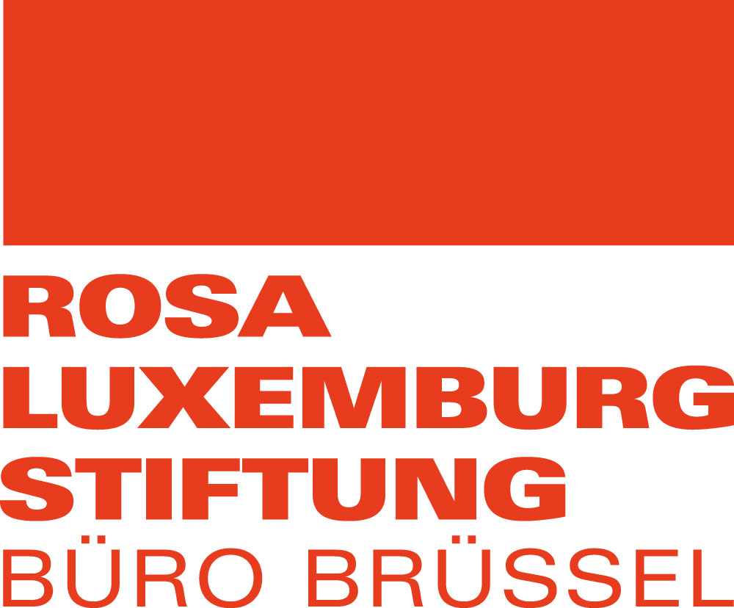  

**Latin America and Europe**

**THE SHAPE OF TRADE TO COME**

**28-30 June**

The International Auditorium, Boulevard du Roi Albert II, 5 - 1210 Brussels

**PROGRAMME**

**Wednesday 28th June: 12:00 – 18:00**

|  |  |
| --- | --- |
| 12:00-13:00 | Sandwich lunch and registration |
| 13:00 – 13:30 | Introduction and presentations |
| **Keynote speech: “The current state of world trade politics”** | |
| 13:30- 14:15 | Geopolitical analysis of the current trade and investment world in a context of crisis of capitalism: the role of key actors (The US, China, BRICS), trends on trade and investment flows, the role of international institutions like WTO, among others. |
| **Panel 1 - Shifting politics and discourse in Europe and Latin America** | |
| 14:15 – 15:30 | This session will discuss the “**Political reconfiguration in Latin America and in Europe and the discourse on free trade”.** It will aim to answer some of the following questions:   * What are the most salient issues in terms of current political dynamics in Europe and in Latin America? * How has the ultra-right has captured the critique of free trade and globalisation? And, how does it differ from ours? * What are the reactions to these changes in discourse in Europe and in Latin America? |
| 15:30-16:00 | Coffee break |
| 16:00 – 16:45 | **WORKING GROUPS:** in light of previous discussion,we will work in small groups to understand **how these shifts in political scenario affect us and our campaigns and what can we do about it.** |
| 16:45 – 17:30 | Coffee break |
| 17:30 – 18:00 | Plenary to collectively discuss strategic priorities |

**Thursday 29th June: 9:00 – 17:00**

|  |  |
| --- | --- |
| 09:00 – 09:30 | Re-cap and objectives |
| **Panel 2 - The Shape of Trade and Investment policies in the EU and Latin America** | |
| 09:30 – 10:30 | This session will discuss the “**trade and investment policy in Latin America and Europe”.** It will aim to address some of the following questions:   * What are the most salient features of trade and investment policy today in Europe and in Latin America? * What have been the impacts of trade and investment relations between EU and LA over the last 10 years? * What happened to the idea of regional integration as a strategy to decouple from an export-oriented model? |
| 10:30-11:00 | Coffee break |
| 11:00-12:00 | This session will give an overview of the “**trade and investment negotiations and agreements between Latin America and the EU”.** Special emphasis will be given to on-going negotiations between EU-Mercosur, EU-Mexico and EU-Chile. |
| 12:00-13:00 | LUNCH |
| **Panel 3 - The State of the Movements** | |
| 13:00– 14:30 | This session will discuss the “**state of trade movements in Latin America and Europe”.** It will address questions such as  - where are campaigns strong? And where are they weak?  - What are the key current/future battles ahead? |
| 14:30– 15:00 | Coffee break |
| **Panel 4 - Defining strategic priorities in the struggles on trade and investments** | |
| 15:00-16:00 | **World café exercise to discuss:**  - the biggest risks we face  - the biggest challenges for 2017-2018  - the key opportunities and battles  - the challenges of movilising against North – South trade agreements |
| 16:00-17:00 | Report back |
| 17:00-17:15 | Wrap up |

**Friday 30th June: 9:00 – 13:00**

|  |  |
| --- | --- |
| 09:00 – 09:30 | Re-cap and objectives |
| **Panel 5 - The Struggles to Come and our Alternative Trade and Investment Agenda** | |
| 09:30 – 11:00 (inc. short break) | In-depth discussion in working groups on a selection of key topics. Working groups will include:   * Modernisation of EU-Mexico FTA * EU-Mercosur FTA * Alternatives to trade and investment * Democratisation of trade policy and CSOs participation in trade negotiations * ICS/MIC and the world |
| 11:00-12:00 | Report back |
| 12:00 – 13:00 | Wrap up |